Learning How to use Matlab/Code Documentation
The current folder panel shows which project folders have been made. The command window is where the user can enter commands for specific tasks. The workspace panel displays all the variables created or imported by the user. The command history shows all the commands that have been entered in the command line. Typing edit in the command window opens the editor. To create a new file, simply type edit 'name_of_file'.m.
I ran this simple function, which takes in an array x and returns both the sum and the length of the array

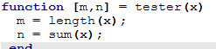

To add comments, just start the sentence with a percent symbol (%). This helps explain what the code is doing without affecting its execution.
Creating an array in MATLAB is simple. For instance, x = [1, 2, 3] creates an array x that stores the values 1, 2, and 3. To create an empty array, use x = zeros(1, 5), which creates an array of five zeros. The first number specifies the number of rows, and the second specifies the number of columns. This would create a 1x5 array of zeros.
MATLAB also allows you to use loops for repeated tasks. To create a for loop, use the following syntax:
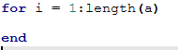

In MATLAB, plotting is a simple and powerful way to visualize data. To plot a basic line graph, you use the plot function.This creates a plot of the sine wave from 0 to 10. The xlabel, ylabel, and title functions are used to add labels and a title to the graph. Additionally, the grid on command adds a grid to make the plot easier to read. Here is an example:
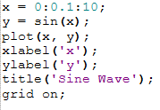

Overview
This program simulates the process of:
- Generating mathematical data,
- Adding random noise (salt) to the data,
- Smoothing the noisy data to reduce randomness,
- Visualizing the original, salted, and smoothed datasets through plots.
The program is organized into four main functions:
- data()
- salt(y)
- smooth(salted_y)
- main_csv()
Each function is modular and handles a specific part of the workflow.

Functions

1. data()
Purpose:
Generates an array y containing 1001 data points based on the equation: y = x^2 +x
for x ranging from 0 to 1000.
Implementation Details:
- Preallocates a zero array of size 1x1001 for efficiency.
- Iteratively calculates y for each value of x.
- Stores results in the corresponding array index.

2. salt(y)
Purpose:
Introduces random noise (called "salt") into the original data.
Implementation Details:
- Creates random values uniformly distributed between −100000 and +100000.
- Adds these random values element-wise to the original array y.
- This simulates real-world data noise.

3. smooth(salted_y)
Purpose:
Reduces the noise in the salted data using a moving average smoothing technique.
Implementation Details:
- Uses a moving window of size 50 elements before and after each data point.
- Calculates the average of nearby points to smooth the data.
- Handles boundary conditions carefully to avoid indexing out of array bounds.

4. main_csv()
Purpose:
Coordinates the execution of the other functions and plots the results.
Implementation Details:
- Calls data() to generate the original data.
- Calls salt(y) to add random noise.
- Calls smooth(salted_y) to reduce the noise.
- Plots three separate figures:
  - Original data
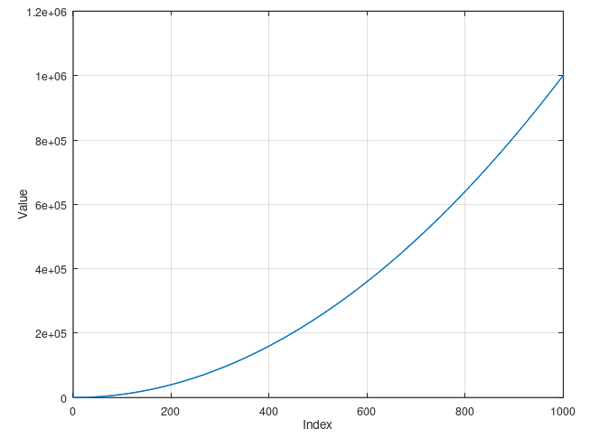
  - Salted (noisy) data
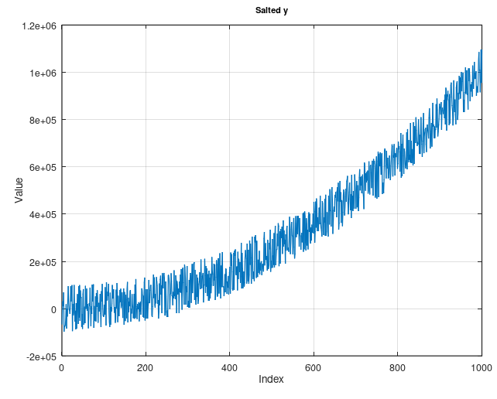
  - Smoothed (denoised) data
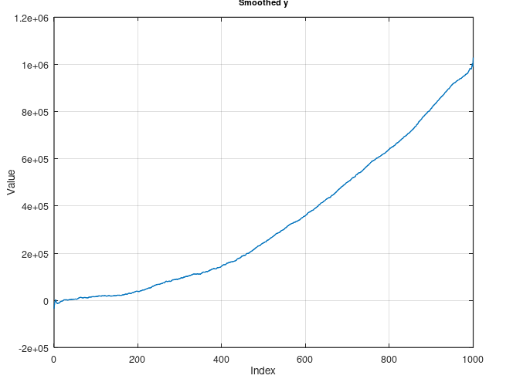

Summary of Workflow
- Generate a clean, predictable dataset.
- Add significant random noise to simulate real-world irregularities.
- Apply a smoothing algorithm to recover a cleaner signal.
- Visualize all stages for analysis.
This code demonstrates basic concepts of data manipulation, noise handling, signal processing, and visualization using Octave/MATLAB.

References:
https://www.tutorialspoint.com/matlab/matlab_syntax.htm
https://www.mathworks.com/help/matlab/learn_matlab/matrices-and-arrays.html
https://www.mathworks.com/matlabcentral/answers/31156-how-do-i-create-a-for-loop-in-matlab
https://www.mathworks.com/help/matlab/ref/plot.html
https://www.youtube.com/watch?v=7f50sQYjNRA&t=2177s

